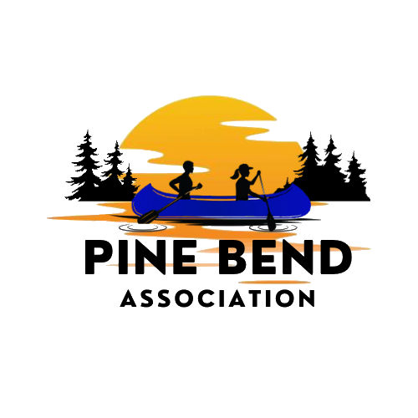
Weekly on Wednesday – July 1, 2026 – Birch Bend Campout September 18 to 20th, 2026
__________________________________________________________________
People who influenced me to do this event.
Gordon Meeker
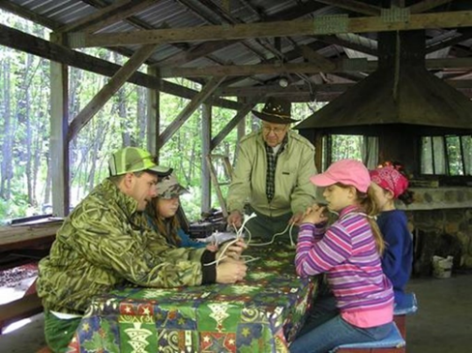
For more than 70 years he was involved with the Boy Scouts. He started at age 9 as a Scout, and in later years served as a Den Leader, Scout Master, Explorer Advisor, and Merit Badge Counselor. Webelos Woods director at Birch Bend until his passing. Gordy is what scouting is all about. I always like to think about the leaders of the past.

Waterfront
There is a waterfront available at camp that includes a beach for swimming with a swim raft. There are no lifeguards provided by the camp.

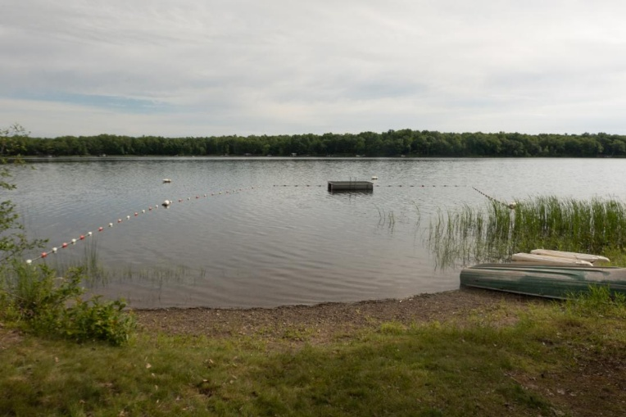
Waterfront picture take 6/26/2026 by Paul Mahowald
Boat Inventory:
There are also watercraft and life jackets available to use. We encourage you to fish while you are at camp.
We have 3 rowboats, 1 raft, 9 canoes, 4 kayaks, 1 fish dock, and 1 two-person foot paddle boat.

Meet the Staff
Paul Kaardal Campout Chair
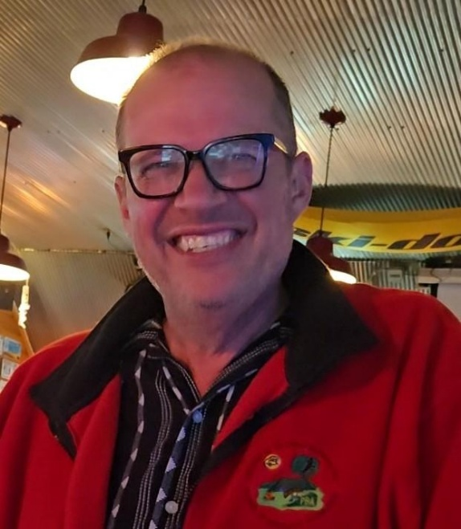
If you have any questions, you can call or text me at: 651-245-1623
You can also e-mail me at: paulkaard@yahoo.com
Highlight a Sponsor
Michael Foods – Hopkins MN
Michael Foods has generously donated pre-cooked eggs to the campout. We would like to thank them for their generosity. If it weren’t for companies like Michael Foods we would not be able to offer this program for no cost



__________________________________________________________________
Eagle Scout Projects
Do your project at Birch Bend. Dozens of projects have been done at Birch Bend over the years.
To Start an Eagle Scout project contact Paul Mahowald at pamaho5729@aol.com


A newer version of this list may be on a clipboard in the Admin Center porch, the west gate tool shed, or online. Camp hosts and members should feel free to add new ideas to either list, send updates to the Property Manager, or cross out projects that have been completed. The Property Manager periodically merges the electronic copy of these lists with the clipboard copies. New projects need PBA board approval before being added. The current version of the Eagle project and service project lists are at:
https://drive.google.com/drive/folders/1nJneYGx2AGDdivbVMpSQYVOeISwNoOFg?usp=share_link

Eagle Service Project Ideas (WG = west gate, EG = east gate) (H, M, or L) = priority
* Conservation related or BSA Distinguished Conservation Service Award possibilities

- * Deer study fence area (L)
- * Water overflow drain (road cattle gate) on road into East Gate (L)
- * Raingarden by WG campsites so water won’t flow directly into Lake (L)
- * West gate group site 1 rehab – ditch and landscaping (L)
- WG campsite 7/8: Tent pads need drainage or rising; EG campsite 9: level some tent pads (L)
- Canvas or steel roofed storage area for 7 wheeled carts near the EG turn around (L)
- 3 new picnic tables, 2 prep tables, and 2 new rickshaws (M)
- Large wood drying cribs by West Gate Pavilion, West Gate group site #1, and WG #13 (M)
- Create a new Charboneau Woods campsite, with firepit, wood crib, picnic & prep table (M)
- * Create a bridge on the White Pine Trail over the low area near Hwy. 51 (L)
- * Clear around a large white pine tree along the White Pine Trail so pine seedlings can grow and re-clear around the Grandmother White Pine. Cage and mark the pine seedlings found (M)
- Create a new trail from East Gate camp site 4 to the pine halfway down the White Pine Trail (L)
- Cut poles for the tipi, install them, and hang the tipi canvas (L)
- Build one or two new outhouses at Charboneau Woods (M)
- Replace outhouse #12 at west gate (M)
- Build bear-resistant pole and cable food hoists to keep smellables from animals (L)
- Install two steel boxes (provided) on a concrete pad to create bear boxes (M)

Projects in process:
- None

New items below need board approval before being added to the approved list above:
- None

