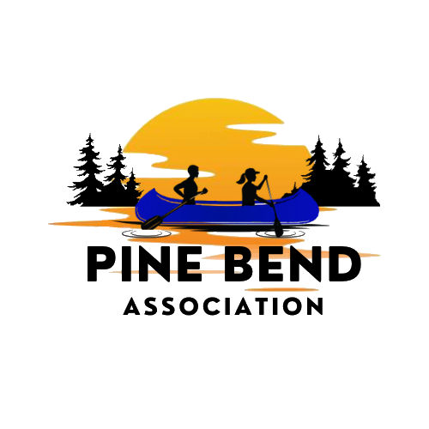
Weekly on Wednesday – July 8, 2026 – Birch Bend Campout September 18 to 20th, 2026
__________________________________________________________________
People who influenced me to do this event.

Paul is the property manager at Birch Bend and knows where tools and other useful items are kept.

What to expect at:
Mile Lacs Indian Museum and Trading Post
When you arrive go inside and you will be split into 5 groups. This will allow maximum time to learn about Ojibwe culture and ask questions.

From the museum website: Explore the story of the Mille Lacs Band of Ojibwe through museum exhibits, objects, demonstrations, and tours, and shop for locally made Native American arts and crafts in the restored 1930s trading post.
The 5 stations you will participate in at the museum are taught by museum staff.
- Four Seasons Room
The centerpiece of the museum is the dramatic "Four Seasons Room," which features life-sized dioramas modeled after actual Mille Lacs Band members. The exhibits draw heavily on the personal stories and oral histories of Mille Lacs Band members.
- Learn 3 Ojibwe Games
- Language – Learn 10 common Ojibwe terms and their meaning. Identify the meaning of 10 Ojibwe place names in the US
- Craft
- Exhibit Hall -
Immerse yourself in the proud and tumultuous history of the Mille Lacs Band of Ojibwe.
When your scouts finish at the museum there will be time to shop at the trading post. When done looking at the trading post we ask you to head to camp. There are only so many parking spots at the museum.

Meet the Campout Staff
Bruce Kaardal – Head Cook - My brother, Eagle Scout Redwood Falls MN
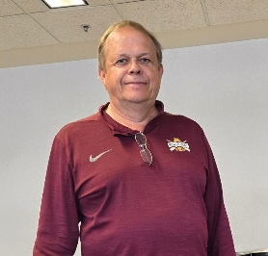
Eagle Scout 1975
Going to the World Jamboree and National Jamboree
Morgan Kaardal – My daughter, could not join Scouts
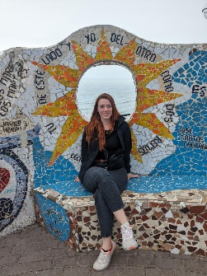
Missed out on having my dad as a scout leader.
Austin Lane – Eagle Scout Troop 90
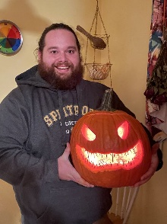
Eagle Scout 2009
Spending all summer camping with friends and traveling all over to go on adventures of a lifetime.
Alex Kaardal – My son, Eagle Scout Troop 90
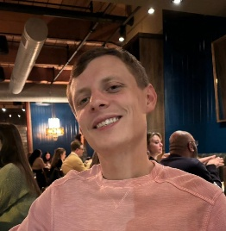
Eagle Scout 2011
Favorite Part of Scouting
I made lifelong friends through scouting.
Alec Lane – Eagle Scout Troop 90
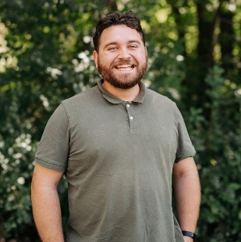
Eagle Scout 2015
Camping and hanging with friends.
Mark Kaardal, My Nephew, Eagle Scout Redwood Falls
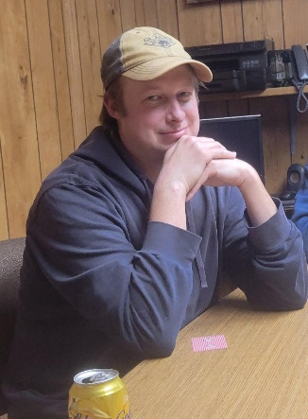
Eagle Scout 2004
I enjoyed camping and high adventure activities.
Adam Lee – Eagle Scout Troop 90
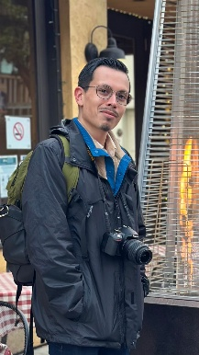
I would say that my most memorable experience of scouting was getting to meet the troop and find out what scouting was over that first one of two weekends (I wasn’t in a scouting organization until Boy Scouts, so it was fun taking it all in)

Danny Vento – Eagle Scout Troop 90
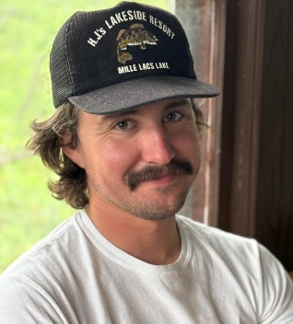
Eagle Scout 2014
Playing capture the flag at camp.
Neil Lee – Condor – Not sure his highest rank
Teaching the Scouts skills.
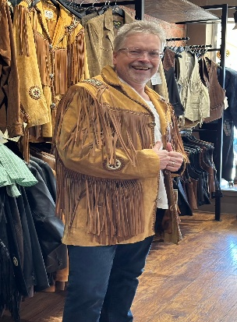

____________________________________________________________________________________
Highlight a Sponsor
Coborns Foods - Mora
Coborns Foods has generously donated pre-cooked eggs to the campout. We would like to thank them for their generosity. If it weren’t for companies like Coborn’s Foods, we would not be able to offer this program for no cost
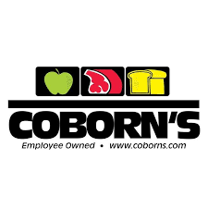

__________________________________________________________________
Did you know there is an Orienteering Couse at Birch Bend?
There are 3 courses.
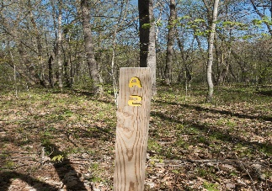
Course A – 8 points

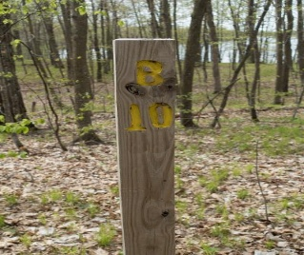
Course B – 12 Points

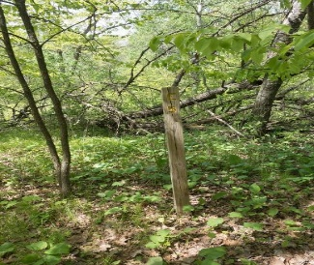
Course C – 10 points

