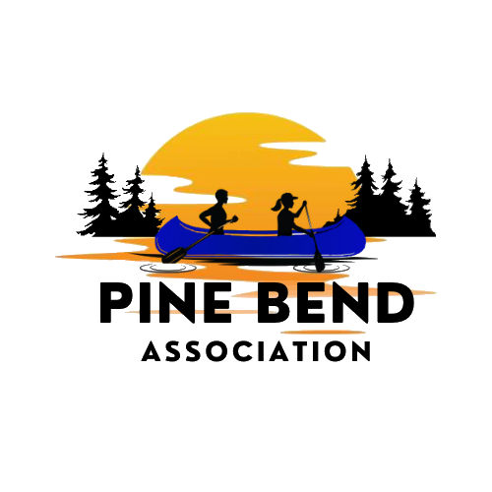
Weekly on Wednesday – July 22, 2026 – Birch Bend Campout September 18 to 20th, 2026
__________________________________________________________________
People who influenced me to do this event.
Mike Vento
When I thought about doing this event again (Last time 2019), I was going to do it in the spring. I didn’t even ask Mike, because we had done them before. Then Mike had medical issues arise and hasn’t been available. So, I switched the event to the fall. Mike is recovering nicely, but needs more time to heal. Scout leaders often become like family. Our successes were many and failures were too. If we failed, it was not through a lack of effort. I am awarding Mike the highest honor I can give-- the Condor badge. I give that badge to all leaders who do not know the rank they finished in scouting. I always look forward to the campfire where we play Ole and Sven. Mike and I have run many events that were attended by more than 100 Scouts. Our largest was 550 scouts in the middle of Saint Paul at a city park. I am hoping he shows up and does the campfire. Scouting is a bond that is hard to break.
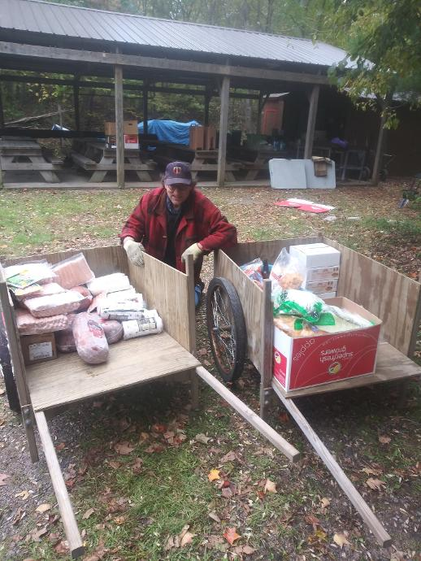
Mike Vento – Rickshaws full of food at last Native American Cultures Camporee

Troops Coming to the Event
Troop 477 is a linked boys (3477) and girls (5477) troop chartered by Christ Memorial Lutheran Church in Plymouth, MN. We serve approximately 50 boys and 30 girls across several west metro school districts. One of our Scout's favorite annual activities is our Arrow of Light camp. We invite local Arrow of Light scouts to join us on camp, where our Scouts plan and execute a themed weekend, blending scout skills with fun culminating in our Saturday campfire and cobbler. In previous years, our themes have been Castaway, Super Heros, and Minecraft. This year, we're taking to the high seas with a Pirates theme. Other big events are our high adventures (20 scouts are going to Philmont this summer), winter camp at Miller Castle, and Summer Camp.

Yours in Scouting
SM Vicki

____________________________________________________________________________________
Highlight a Sponsor
Casey’s
Casey’s has generously donated 20 dozen donuts to the campout. We would like to thank them for their generosity. If it weren’t for companies like Casey’s, we would not be able to offer this program for no cost

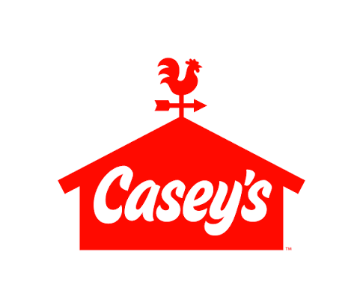
____________________________________________________________________________________
Did you know there is an Archery Range at Birch Bend?
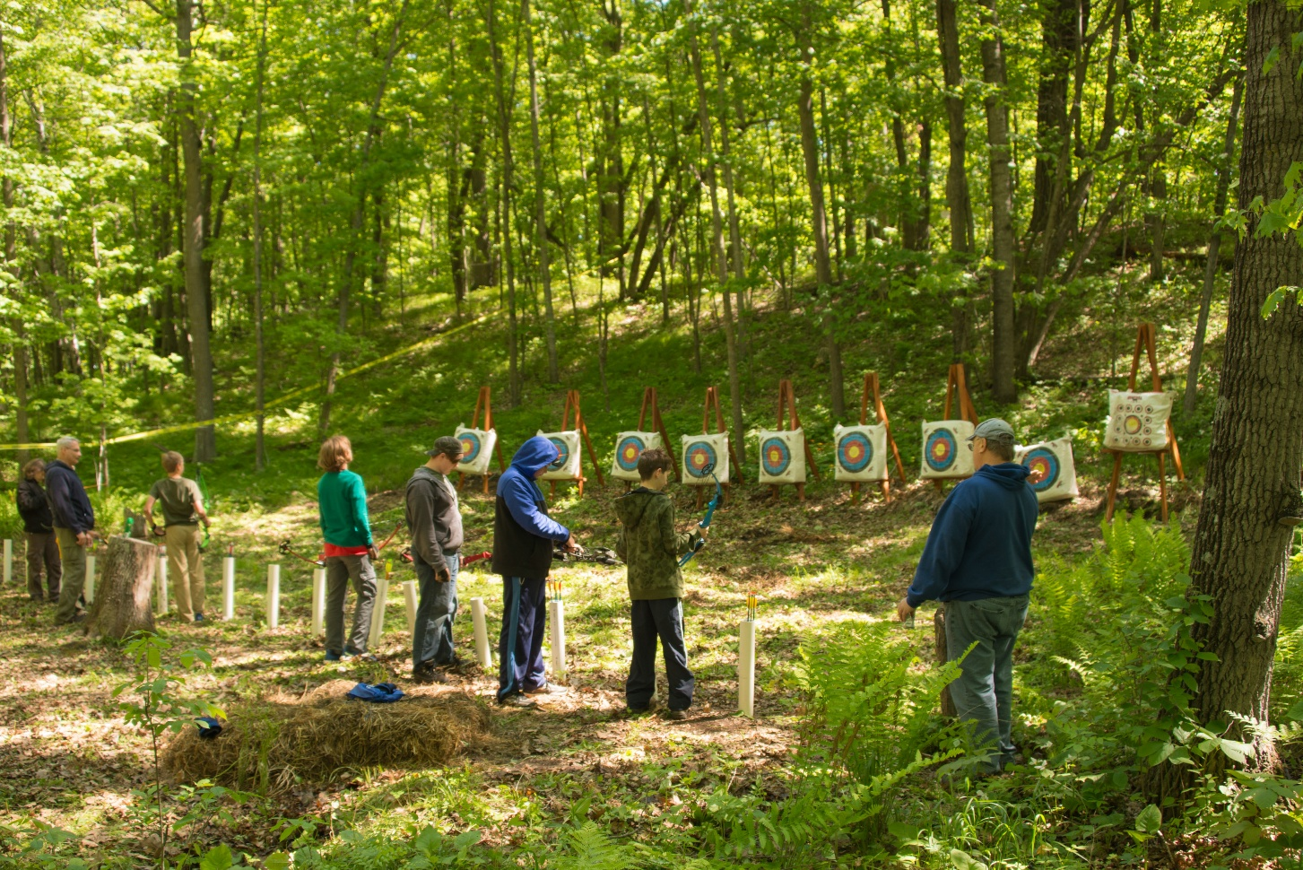

By the way,
Paul Mahowald – Property Manager
Please do not bring firewood to camp. Lots of free wood is available at camp. If any adult wants to split wood as a service project, the scouts could haul and stack wood.

