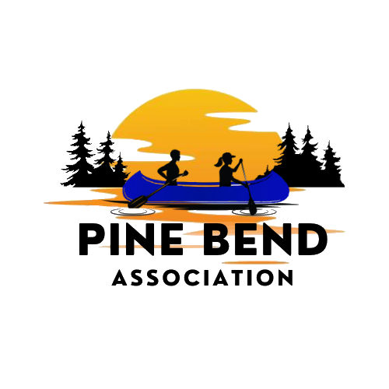
Weekly on Wednesday – July 29, 2026 – Birch Bend Campout September 18 to 20th, 2026
____________________________________________________________Pine Bend Association Cabin
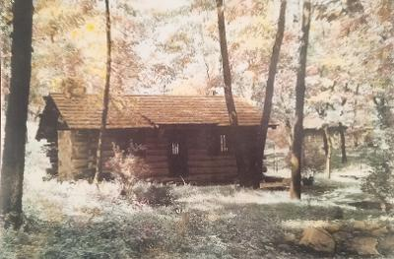
The Pine Bend Association owned this cabin.
This property was sold in 1957 for $45,000. The development of the Pine Bend Refinery next to the land the cabin was on made the land less desirable for youth to use. It was in the refineries’ best interest to buy the land from the Scouts.
In the next issue how Birch Bend Campground was created.
Troops Coming

Troop 1
Troop 9001 and Pack 9001 are located at Church of St Mark in St Paul. Both are in a rebuilding phase. Pack 1 has over 30 Cub Scouts. Troop 1 honored 3 Eagle Scouts last year. The scouts completed their Eagle Scout projects at or near Birch Bend Campground. The Church of St Mark has continuously supported Troop “1” since 1910.

Troop 33
Troop 33:
Downtown Minneapolis
Westminster Presbyterian Church
Founded in 1918, the troop only had 6 real Scoutmasters during that time, (a couple fill-ins on paper during WW2). In addition to 2 two-week sessions of summer camp at Camp Ajawah, (which our Troop founded in 1921), every summer they go on a 1 week quasi high adventure trip to a place that is entirely picked by the Scouts, with no input from the adults.

Troop 187

Troop 187 was chartered by Creekside (formerly known as Mayflower) Church in Minneapolis, Minnesota in 1929. Camping is the heart of our scouting program and monthly campouts give youth a taste of the great outdoors in all seasons, providing opportunities to learn about teamwork, self-discipline and leadership. Creekside’s Troop operates its own 120-acre facility, Camp St. Croix, using it for winter campouts, a two-week summer camp, and other scouting activities throughout the year. Parents play an essential role in the program.

____________________________________________________________________________________
Did you know there is a bouldering wall?
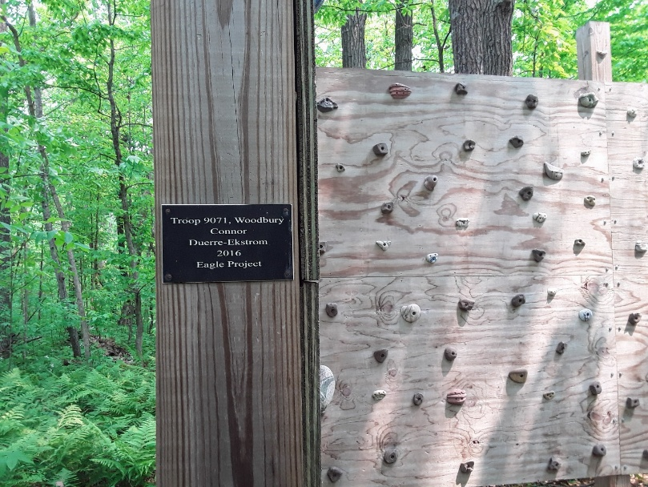

____________________________________________________________________________________
Highlight a Sponsor
Target donated a gift certificate to help with the cost to feed everyone. We would like to thank them for their generosity. If it weren’t for companies like Target, we would not be able to offer this program at no cost


____________________________________________________________________________________

