
Weekly on Wednesday – August 5th, 2026 – Birch Bend Campout September 18 to 20th, 2026
Buying Birch Bend –
Next week buying Charbonneau Woods
In 1959, a property located southwest of Mille Lacs Lake was purchased by the Pine Bend Association. A short time later, the son of one of the old Pine Benders, seeing the birch trees on the new property surrounding the southeast shore of our beautiful lake, dubbed the place Birch Bend.

There are 320 mostly timber-covered acres, the use of which is limited only by their imaginations. Round Lake (which is not round) is 25-30 feet deep, with sandy beaches and a good variety of fish. The Platte River connects the lake with nearby Sullivan and Platte Lakes. Wildlife includes pheasants, ducks, deer and small game.

So it begins. We have started purchasing Items
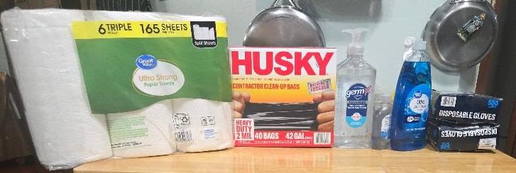
Cleaning supplies and hand-washing supplies.
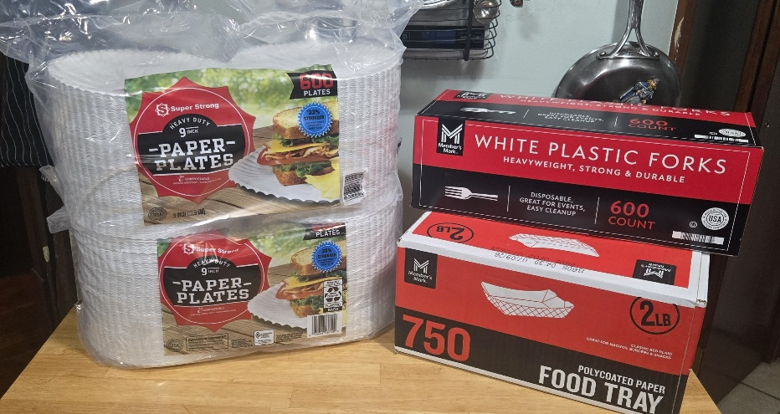
Paper Products
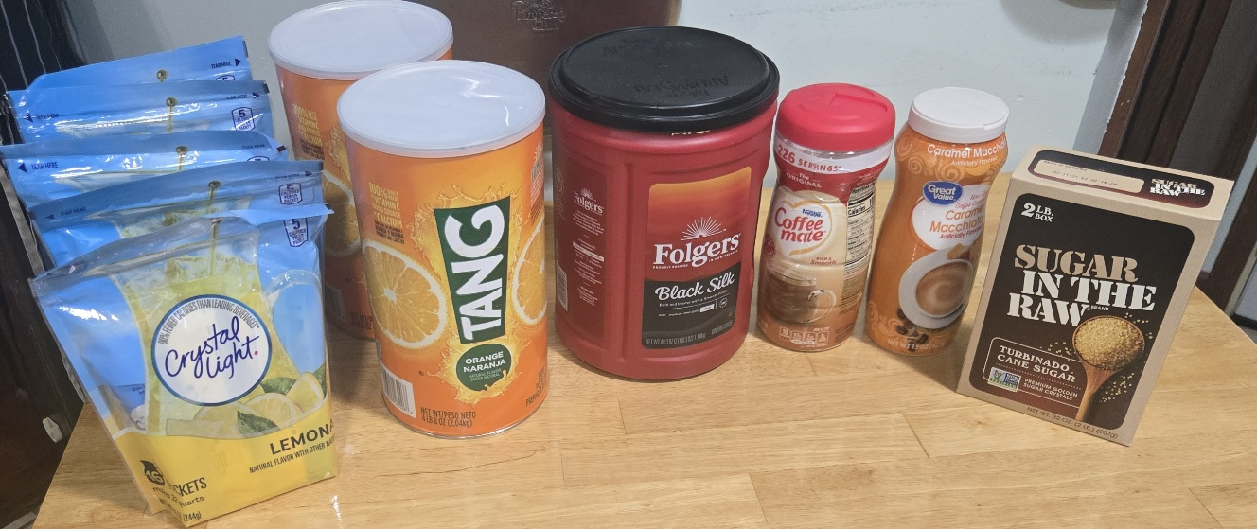
Drink Station
______________________________________________________________________________

Troops Coming

Troop 9
Duluth, MN
Glen Avon Presbyterian Church
107 years since founding
Family Troop, with male and female scouters.

____________________________________________________________________________________
Picture of the boat racks?

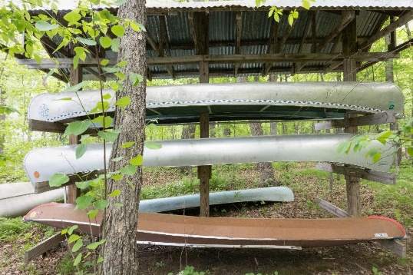
Canoes and kayaks are available
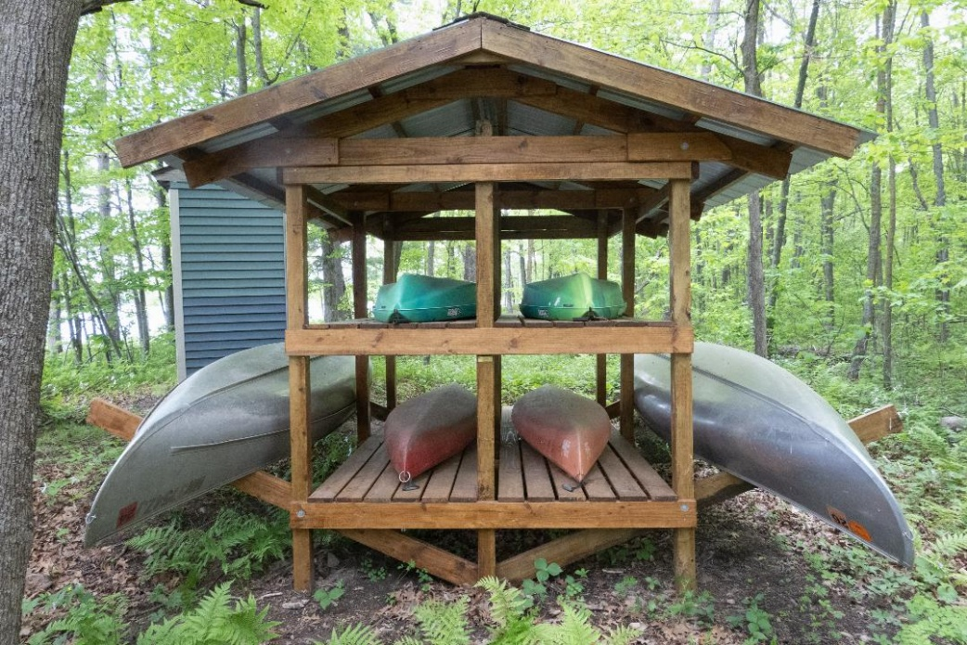

____________________________________________________________________________________
Highlight a Sponsor
Costco donated a gift certificate to help with the cost to feed everyone. We would like to thank them for their generosity. If it weren’t for companies like Costco, we would not be able to offer this program at no cost.

____________________________________________________________________________________

