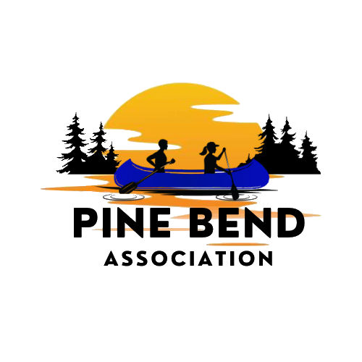
Weekly on Wednesday –August 19, 2026 – Birch Bend Campout September 18 to 20th, 2026
__________________________________________________________________
People who influenced me to do this event.
Darrel Charboneau

College of Wildeness Knowledge(CWK) camp host and instructor since 2003. I teach Archery. Canoeing, Orienteering, Cycling, Archaeology and Wilderness Survival. Co Director of the CWK program from 2010 to 2023. Pine Bend Member since 1973 and a past President.

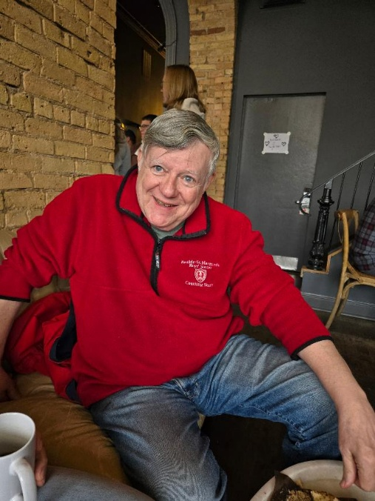

Charboneau Woods Property

Charboneau woods is an 11.5 acre property on the northwest corner of Round Lake. It represents an extension of the campus of Birch Bend Campground and is available for use by youth groups as part of the College of Wilderness Knowledge (CWK) programs. Units may drive to the site at Charboneau Woods, or they may take an “adventure” by canoeing over to the sites from the Birch Bend campground on the south side of Round Lake. This property potentially also offers access during the winter months as the Roundview Road access is plowed. The Charboneau Woods property is still being finalized with much of the work being completed by Eagle Service Projects.
The Charboneau Woods property was originally purchased from a land owner who agreed with the goals of keeping this property in a relatively primitive state. It was purchased by a combination of the Pine Bend Association, the Pine Bend Scout Club Foundation, and some individual donors.

Hi Everyone:
I received these requests from two Eagle Scout candidate brothers. It looks like the brothers will have most of their projects done over the 2 weekends before and are just looking for many hands to remove any leftover brush. Troop 1 from Saint Paul will be up the weekend of September 18th to 20th. If the projects are not finished Owen and Fintan have asked to talk during morning announcements.
These projects would finish the goal of having 5 completed campsites at Carbeneau woods.
Have a great day,

Paul Kaardal

Charbeneau Woods Campsite #4
Owen Bergson Request:
My name is Owen Bergson and I am a member of Troop 1. This September I will be going up to Birch Bend to complete my Eagle Scout Project. I hope that you may want me to assist me in my endeavor. We will be assembling a prep table, wood rack, and a picnic table in Saint Paul and transporting them to Birch Bend. We will also be installing a metal fire ring at the campsite. A crew of us will go up the week before and clear the site and place the tables, fire ring, and wood rack. I would appreciate if your troop would come over to Charboneau Woods (another part of Birch Bend) and help carry the brush and make piles to be burned.

Charbeneau Woods Campsite #5
Fintan Bergson Request:
Hello, my name is Fintan Bergson. I am a Life Scout in Troop 1, and I am asking for help to complete my Eagle Scout project. It includes building a campsite with a fire ring, a picnic table, a preparation table, and a wood box at Birch Bend Campground in Minnesota. I will have all of those things installed before you arrive at Birch Bend. We will also go up the weekend before and cut all the brush and trees and have them on the ground. I am asking if anyone is available to help clear any brush and carry it to a brush pile to be burned. This project is on the Charboneau Woods side of camp.

____________________________________________________________________________________
Highlight a Sponsor
Tolzman distributing 240 bags of Utz chips.
We would like to thank them for their generosity. If it weren’t for companies like Michael Foods we would not be able to offer this program for no cost

____________________________________________________________________________________

