We have your reservation to the Birch Bend All Inclusive Campout
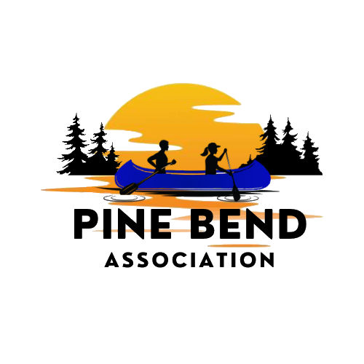
Dates: September 18th to 20th, 2026
Where: Birch Bend - College of Wilderness Knowledge
33082 268th St., Pierz, MN 56364
Keys to smooth campout
- Arriving at camp there will be leaders at the gate to direct you in. If a car must leave, we will hold traffic at the gate for a smooth transition in and out at check in. If you are bringing a trailer, let us know. We will let you drop off gear at the campsite and park as near as possible. All other vehicles must park in the designated parking lot. There are rickshaws available to haul gear to the site.
- You will be assigned to Group A or Group B. This will let you know when you will be going to the museum, in the morning or the afternoon. It will also tell you when you will eat breakfast. In the morning group A will be served breakfast first, then head to the museum. This will make sure they get there on time.
- Scouts should bring a water bottle. Anyone who wants coffee should bring a coffee cup. Limited glasses will be available. Please share the packing list with scouts.
- Troops should bring a water dispenser for their campsite. There is a pump on site for everyone’s use. It is important for everyone to stay hydrated.
- All troops should have a skit ready for the campout in order to have a blast. Individual scouts can bring jokes to join in with our campfire crew.
- Enjoy your time. This is why we are running a campout.
Units Attending:
Troops: 3233 Anoka, 5477 Plymouth, 292 Apple Valley, 9001 Saint Paul, 2009 Duluth, 3001 Minneapolis, 2044 Duluth, 3187 Minneapolis, 3033 Minneapolis

Form 1
2026 American Indian Culture Merit Badge Campout
Print additional forms if you have more than 14 scouts coming

Troop Scoutmaster:_______________________ Senior Patrol Leader:____________________

Troop Number _____________________

Scout’s Name: Current Rank:
1)
2)
3)
4)
5)
6)
7)
8)
9)
10)
11)
12)
13)
14)

Leader's Name:
1)
2)
3)
4)

Note: Health forms are required. Please bring them for everyone. If you do not have forms you may print them from the council website.

2026 American Indian Culture Merit Badge Campout
Packing List – Share with Scouts and Leaders
- Tent – If troop does not provide
- Sleeping pad, sleeping bag, pillow
- Outdoor folding chair if possible – Picnic tables may be needed at pavilion
- Water bottle – There will be very few cups available. Please bring water bottle.
- Coffee cup if you drink coffee
- Hygiene – toothbrush, toothpaste, deodorant
- Flashlight or headlamp
- Bug spray and suntan lotion
- Class A uniform
- T-shirts, shorts and pants
- Rain jacket or poncho, warm fleece/jacket, and a hat
- Closed toe shoes

