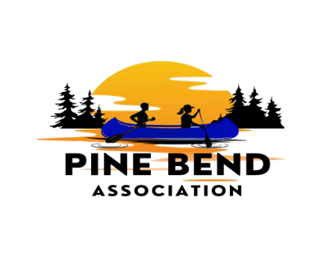
Weekly on Wednesday – August 26th, 2026 – Birch Bend Campout September 18 to 20th, 2026
____________________________________________________________
People who influenced me to do this event.
Jean Keller

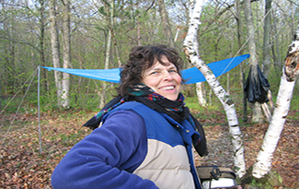
Associate Dean of the College of Wilderness Knowledge, Reservations & Scheduling
Instructor: Astronomy, Indian Lore, Orienteering, Forestry,
I have been camping at Birch Bend since 1960. Besides camping with my parents and family when I was growing up, I raised 2 children camping, swimming and hiking through the woods at Birch Bend. My son (an Eagle Scout) is our third generation to bring his family with small children to Birch Bend. My experience includes being a teacher for 20 years, a Girl Scout leader and an Assistant Scoutmaster with boy scouts. My family also served as host parents to children from 9 countries.
I am looking forward to teaching courses at Birch Bend again this year

Things for troops to bring:
- Water dispenser for your campsite- I would pick up some lemonade mix for your water. This is well water. If your scouts are used to river water like the metro area it will be totally different. My grandparents had well water on their farm. There is a difference between the two.
- Ask all scouts to mark their water bottles and chairs with Troop # and name. We will have a lost and found and this will speed up the process. If you can bring tape and a marker to mark any scouts who forget to mark theirs, that would be great.
- Form 1 in the welcome packet that was sent to you- I do not expect you to find that email. Just go to the link below (open Welcome to Campout):

https://www.pba-cwk.org/2026-american-indian-culture-event/

Just fill it out. It is the only form for the campout.
- Bring your health forms. We will not collect them. Better safe than sorry.

Have Fun
It is time to Play

Map of Campsites
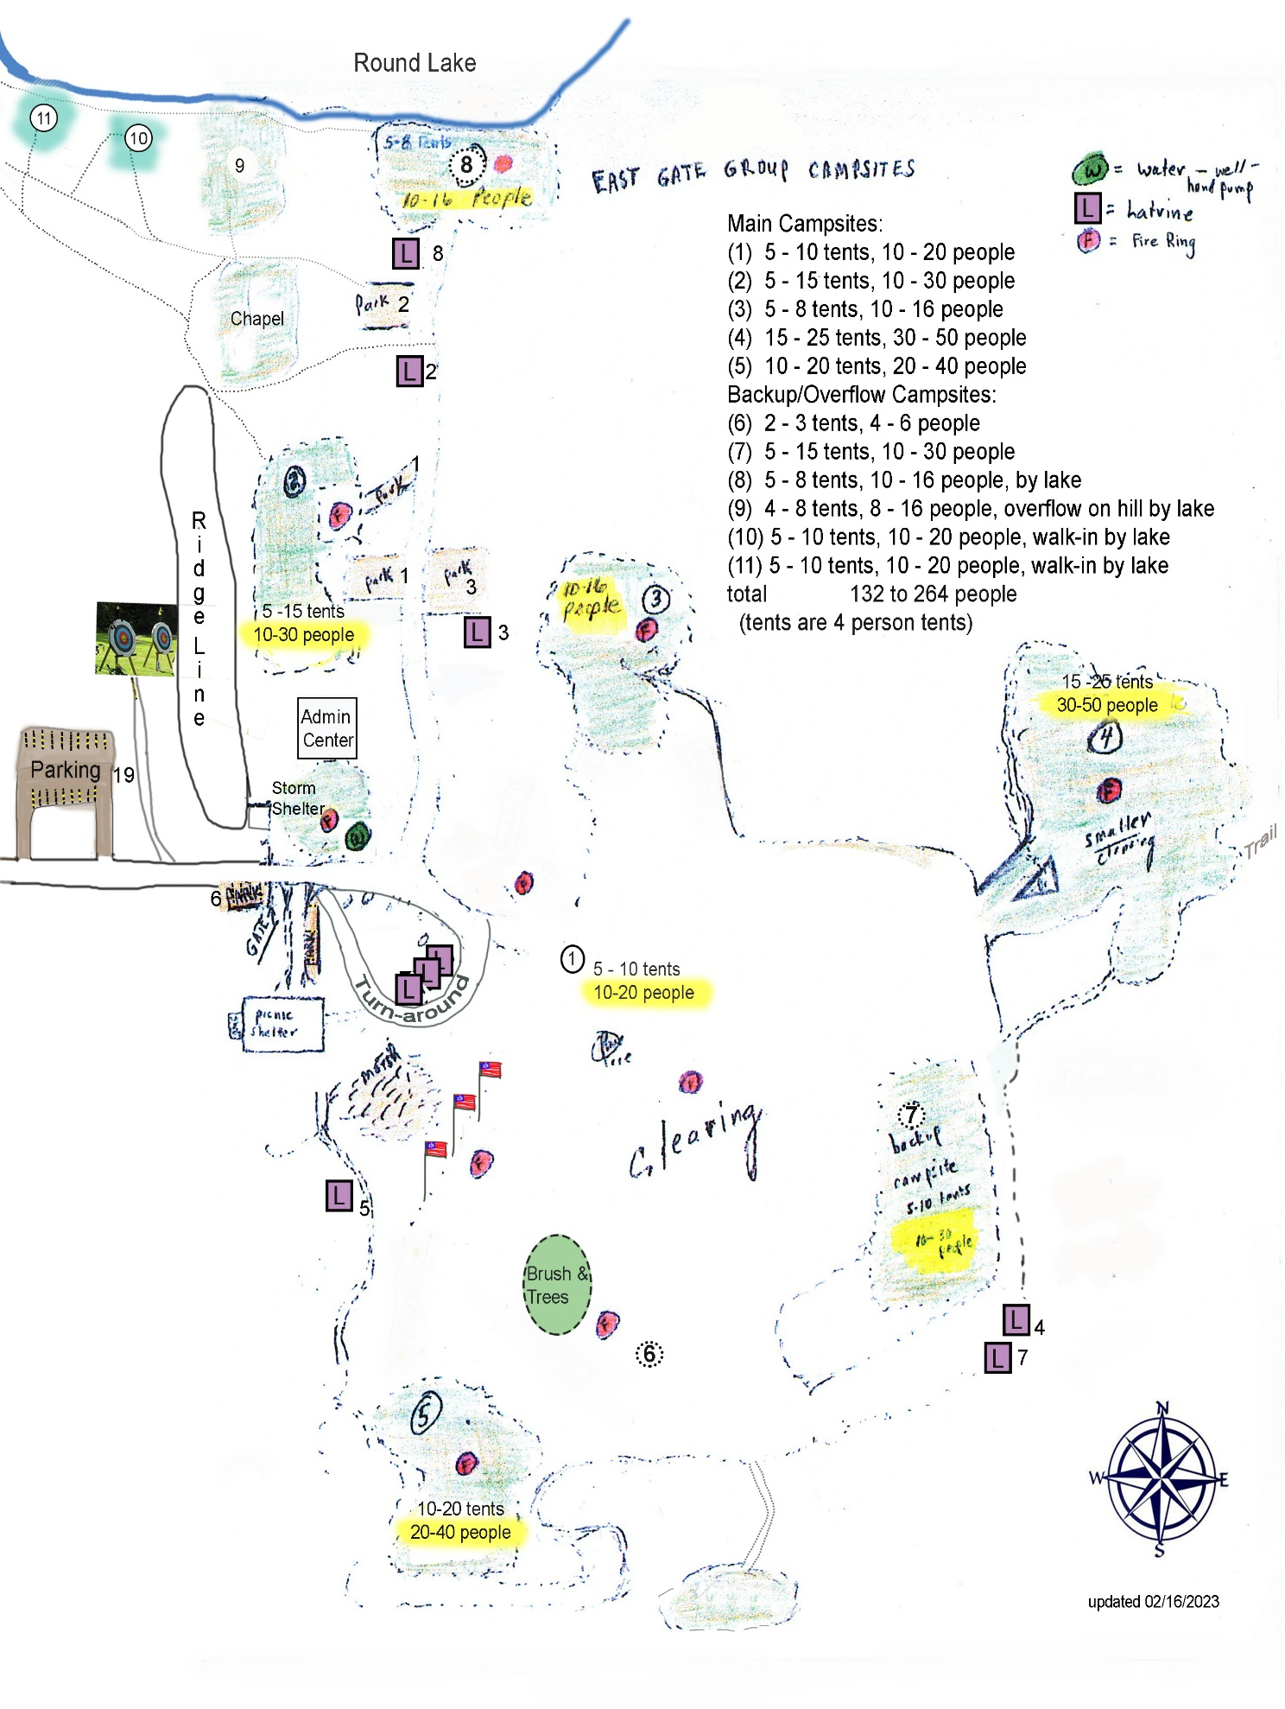
What will be in your Welcome Packet:

- Red or blue wristbands, depending on which group you are in. 1 per adult and scout.
This designates morning or afternoon at the museum and can be removed after breakfast.
- Orange or Yellow or Green Wristbands, depending on which group you are in. 1 per adult and scout.
This designates which group you are in at the museum. This can be removed after your visit to the museum.
- Schedule, Red (A) or Blue (B), depending on which group you are in. We did not provide one per person. Scoutmaster and senior patrol leader should have them. The schedule is also posted at the picnic pavilion.
There will be sheets of paper with addresses of where to park at breakfast if you need them. Otherwise, you can put one of these addresses in your phone.
_________________________________________________________________________________
Museum Parking
- Parking has 2 locations – Government Center is across the street.
- Mille Lacs Band of Ojibwe Museum
43411 Oodena Dr, Onamia, MN 56359
- Mille Lacs Band of Ojibwe Government Center
43408 Oodena Dr, Onamia, MN 56359
Our Final Sponsors – My Friends and Son:
Josh Independent Distributer of Little Debbie – 60 bags of donuts
Dave Independent Distribute of Pepperidge Farms Bread – 60 bags of top loading hot dog buns
Alex and me – Independent distributer of Mission products – Tortillas, Chips, and Salsa

I would like to thank my friends and all those who donated products to make this a great event.
Recap of Sponsors
Campout Sponsors
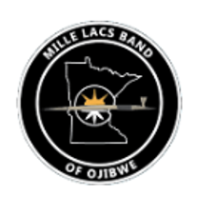

Tate Independent Distributor of UTZ chips
Josh Independent Distributor of Little Debbie
Dave Independent Distributor of Pepperidge Farms
Alex and me Independent Distributors of Mission Products

